**CTF Topic: Analyzing Admin Tools with the Admin Tools Chrome Extension**

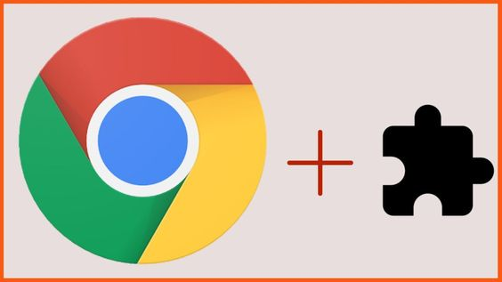

**1. Introduction**

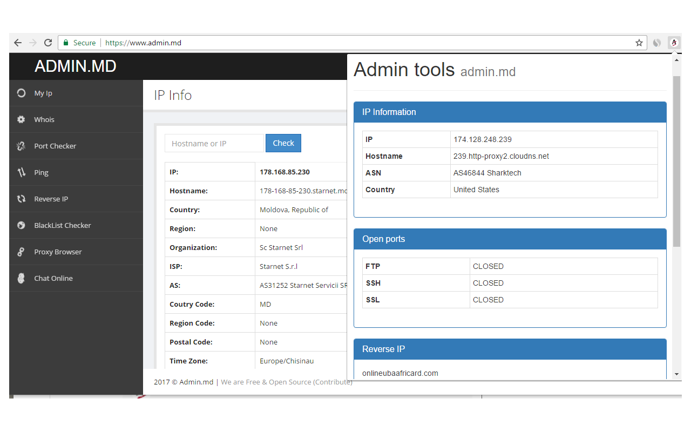

Admin Tools is a Chrome extension designed to assist in analyzing administrative functionalities and configurations of web applications. It provides insights into the backend operations and settings that are crucial for administrators and developers.

**2. Tools and Requirements**

Google Chrome browser

**3. Scenario**



As a participant in this CTF challenge, your task is to use the Admin Tools Chrome extension to analyze administrative functionalities on `<http://testphp.vulnweb.com/> `. Explore the application and answer the following questions based on your findings.

**4. Process to Follow while Performing CTF**

1. Install the Admin Tools Chrome extension from the provided link: **(**[**https://chromewebstore.google.com/detail/admin-tools/ngednhgpggnkpgeajmaijmmlghmbfiep**](https://chromewebstore.google.com/detail/admin-tools/ngednhgpggnkpgeajmaijmmlghmbfiep) **)**  
2. Visit **`**[**http://testphp.vulnweb.com/**](http://testphp.vulnweb.com/)**`** and use the extension to analyze various administrative aspects.

3. Utilize the extension features and Solve the CTF.

**Questions and Answers**

Flag 1: Use the Admin Tools extension to identify the ip of `http://testphp.vulnweb.com/`. What is the IP address of it ?

Answer: 44.228.249.3

Flag Captured.

Flag 2: Which country this ip belongs to?

Answer: United States

Flag Captured.

**Hint**

Install the Admin Tools Chrome extension and explore different aspects of `http://testphp.vulnweb.com/` related to server technology, HTTP headers, open ports/services, cookies, forms, and security headers. Use the extension features to gather information needed to answer the questions accurately.